MGT 656 - Class Project

Software Development Project Status Report

Project Final Report- Sprint 7

Professor Kyle Jensen



Team: Morning-Leaf

Members:

Raúl Madriz raul.madriz@yale.edu

Ernesto Reyes ernesto.reyes@yale.edu

Ernesto Castillo ernesto.castillo@yale.edu

Carlos Romo carlos.romo@yale.edu

December 11, 2015

**Final Project Report - Sprint 7**

Heroku application address: (<http://mgt656-morning-leaf.herokuapp.com/>)

Version control: (<https://github.com/Morning-Leaf/morning-leaf-reporting>)

**Burndown Chart**

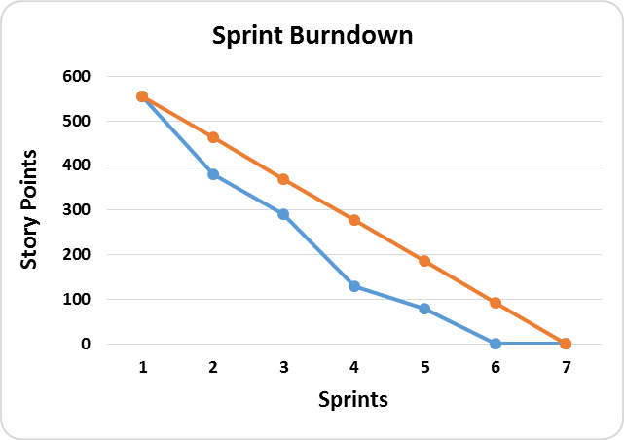

**Labels**

**Ideal Burndown**

**Actual Burndown**

**Sprint Completed Stories**

1. Analyze traffic data to our site (This due to the fact that we have just finished the tasks for this user story)
2. Extras that the site might need

During the Sprint 7 the team was very well organized, because we already knew the activities that we were going to work and develop for the final sprint. As a general comment we think that the project has being very interesting and it has had difficult points for all the team members. But a very important thing that has helped us a lot to minimize difficulties is our weekly meeting that we had every Thursday. During this meeting the team had the time to discuss and address important issues that we encountered in some tasks that were developed of the user stories that we created for our project. In general we can definitely affirm that team meetings are a key part for every project in a scrum environment. During our last meeting we discuss the finals activities that had to be developed for the project. We didn’t had any big issue with the activities that were developed and concluded. **The only issue that we had was that we were curious about what the stakeholders will want as a final presentation for the project. We e-mail that question to the main stakeholder and he gave us feedback on an open e-mail to all the teams.**

During Sprint 5 we finished the user stories 11 and 12. This led us to a result of 80 story points for this sprint. From the 555 story points that we reestimated for the 7 sprints of the final project, we have completed the 555 story points which lives us with 0 story points at the moment. We have been able to manage more than 93 story points per sprint that would have been the ideal burndown chart. The estimations that we did since the beginning have been very accurate with what we expected and we have just reestimated our burndown chart one time. We have been using waffle to distribute the activities and also we have google docs so that all the team members can be informed of the tasks they have to deliver. But the most important the team meetings that we have every week to discuss the important issues of the project have really helped our project to succeed and advanced.

**Sprint Backlog**

During Sprint 7 we were able to manage and finished all the tasks that we had planned for the sprint that were tasks 2 and 3 from user story 11 and tasks 1 and 2 from user story 12. Also we have begun to analyze traffic data to our site.



**Product Backlog**

During sprint 6 we finish all the user stories that we had been asked to do and the reestimated issues that were important to have in our application like the google analytics issue that stakeholders wanted. At the moment we don’t have any product backlog for user stories, all have been concluded. We are waiting for future user stories that may come from stakeholders. In the next chart we show all the user stories that were developed during the 6 sprints of the project.

For Sprint 7 the Project Final Report we are going to work on the following tasks:

1. Future user stories that may came from stakeholders
2. Analyze traffic data to our site (This due to the fact that we have just finished the tasks for this user story)
3. Extras that the site might need

**What is Morning-Leaf Developing?**

We will also want to remember you our stakeholders that the application that we are developing is an application that allows users to create and RSVP for upcoming events. During each sprint our application has been improving. At the moment the application looks like the next figures 1, 2, 3, 4, 5, 6, 7, 8 and 9.

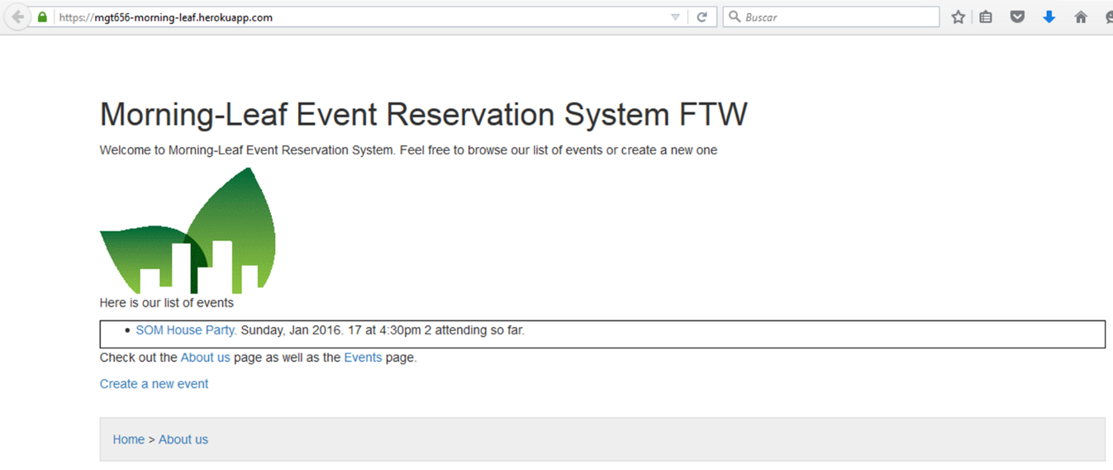

***Figure 1***

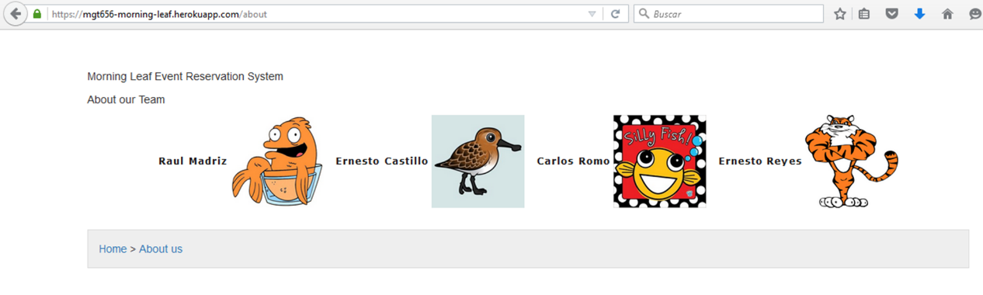

***Figure 2***

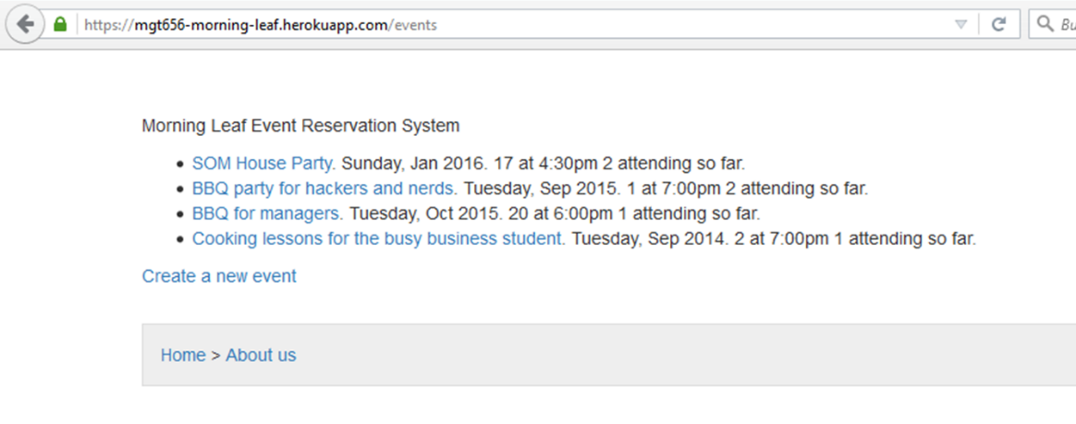

***Figure 3***

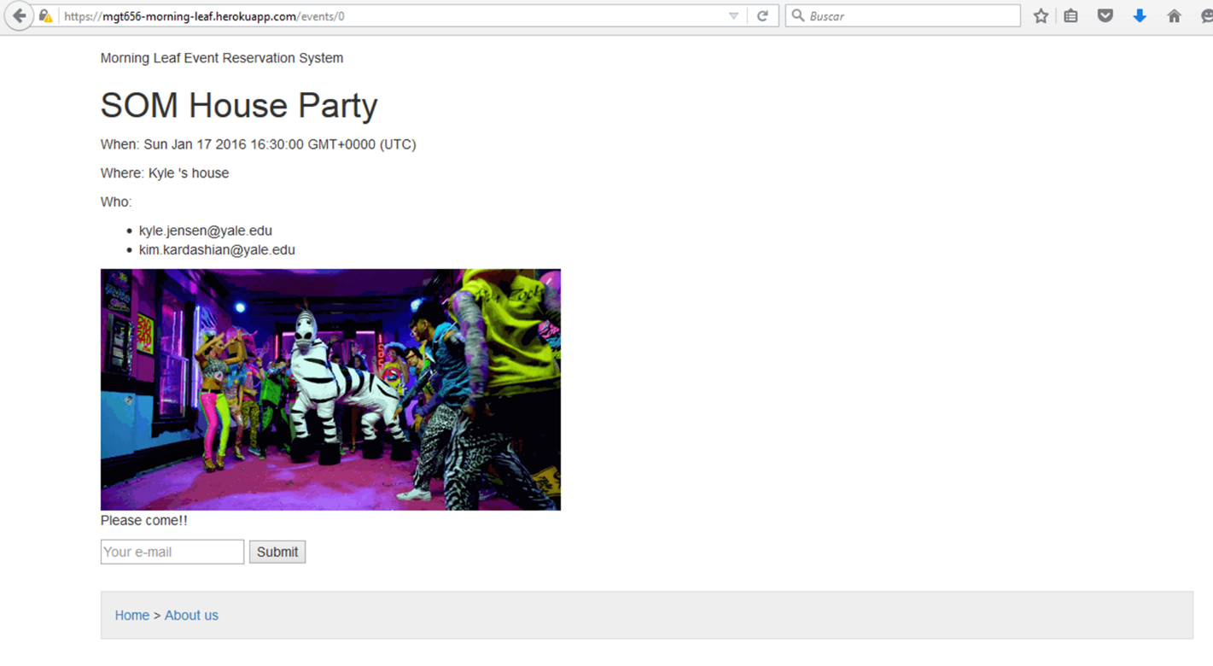

***Figure 4***

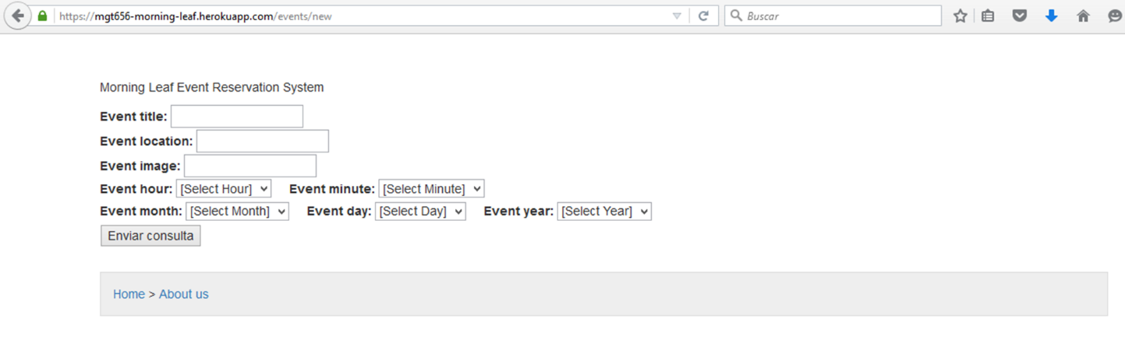

***Figure 5***

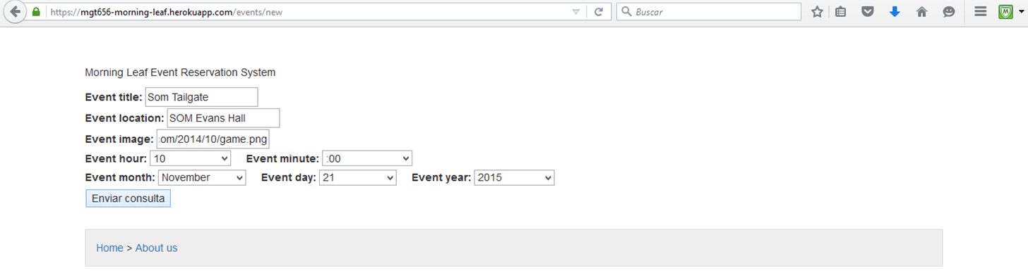

***Figure 6***

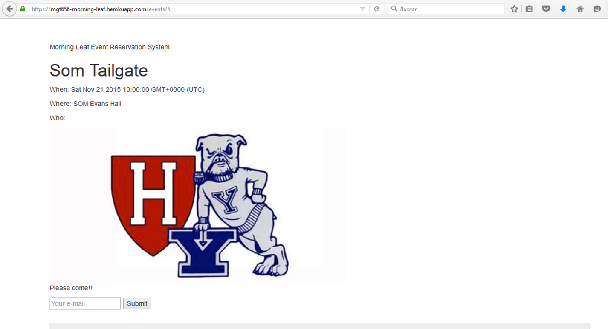

***Figure 7***

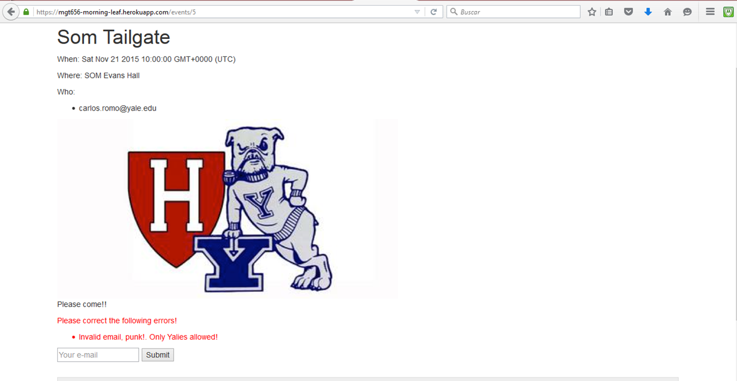

***Figure 8***

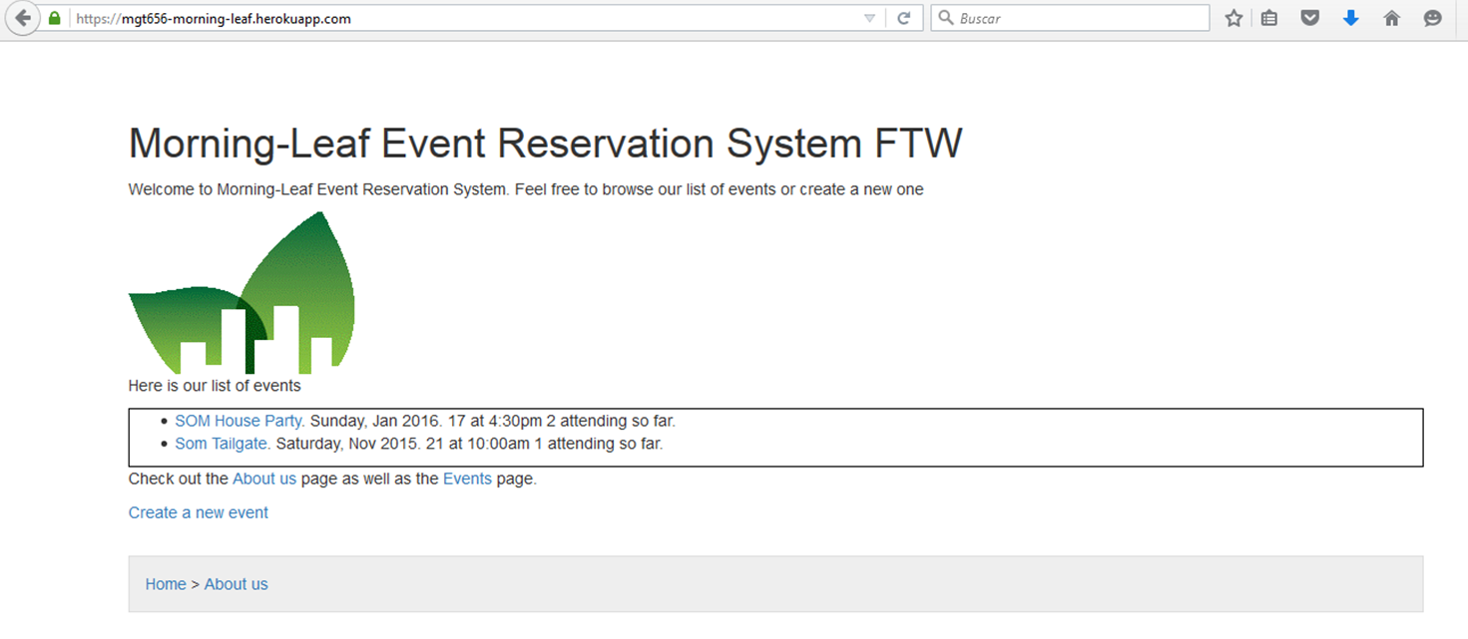

***Figure 9***

For this Sprint in figures 10 and 11 you will see the layouts that we are going to use on the application. The layout that was developed by the team was changed. Also we show you some of the code of google analytics in figures 12, 13 and 14.



***Figure 10***



***Figure 11***

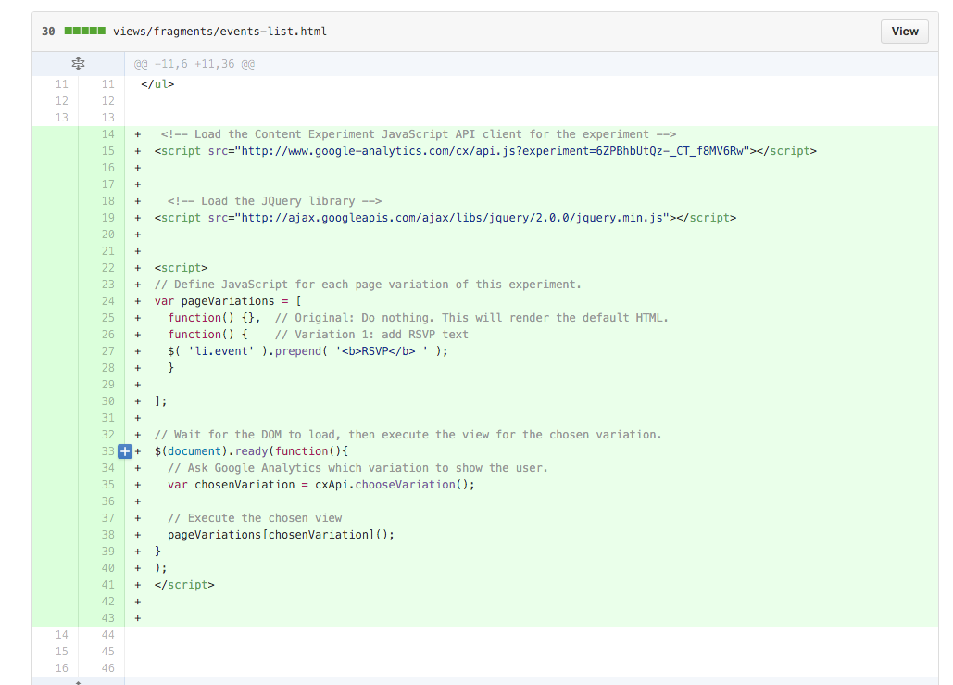

***Figure 12***

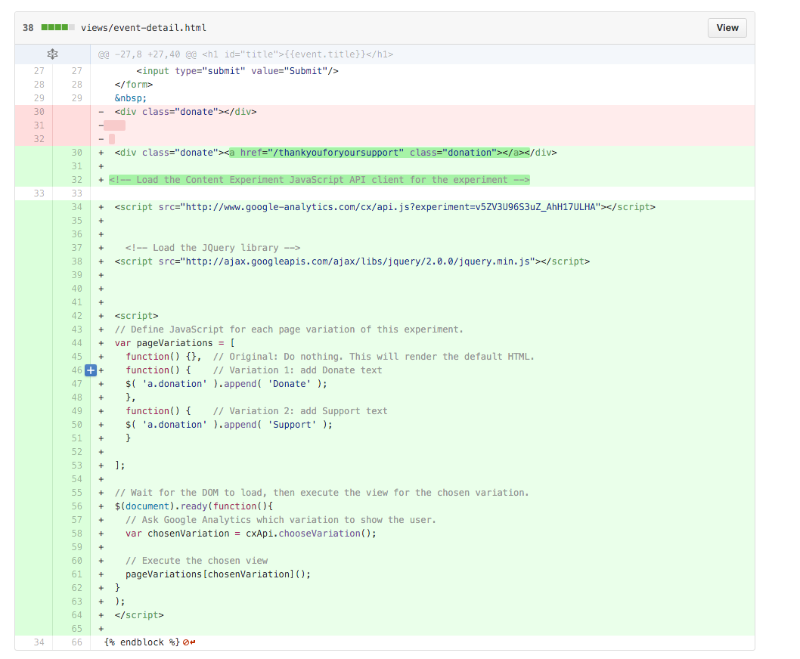

***Figure 13***

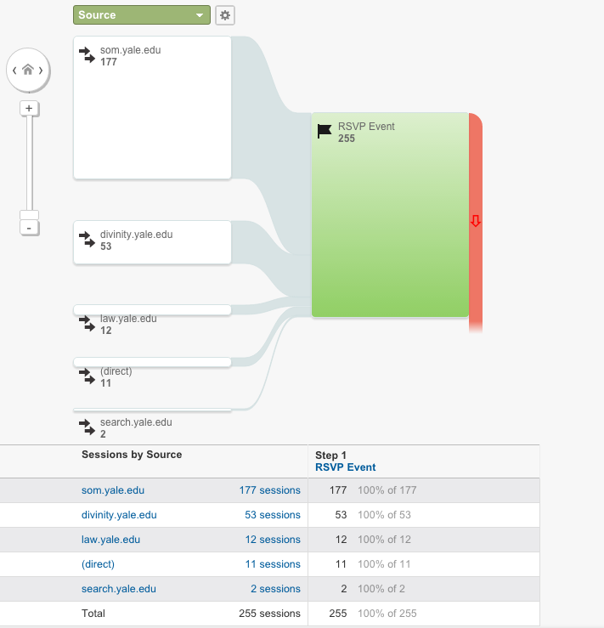

***Figure 14***

We hope that with this information you have a better knowledge of what the team Morning-Leaf has been doing to develop this application and the importance of the team on delivering high quality on the product. During this sprint we finished all the user stories that we had for the project. In next sprint we will be adding extras that may be needed to have an awesome application.